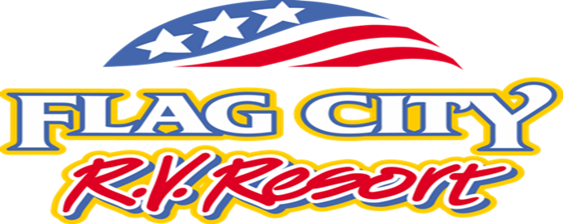

April 1, 2022

Dear Flag City RV Resort Patrons,

We hope this correspondence finds you doing well and staying healthy. As of May 1, 2022, our rates will be revised as specified below. In line with our past practice, discounts from RV membership programs will still be applicable to our Daily rate.

Daily - $85
Weekly - $475
Biweekly - $900

This rate adjustment is important to ensuring we maintain the amenities and overall experience you have come to expect at our resort. Rate changes will be implemented for transactions beginning May 1, 2022. Please feel free to reach out to the main office (contact number below) with any questions. We thank you for being a valued patron.

All the best,
Flag City RV Resort

(209) 339-8300
info@flagcityrvresort.com

